

accessing remote software servers
Dominican University provides several, popular software packages to the community via the remoteapp.dom.edu and cists.dom.edu server. To access the software packages, follow the direction below:
From On-Campus using Windows:
- Open a web browser and go to https://remoteapp.dom.edu
- Enter the following data and then click Sign in:
  - In Domain\username, enter dom\ and then your username (ex: dom\tdkleine).
  - In password, enter your email password.
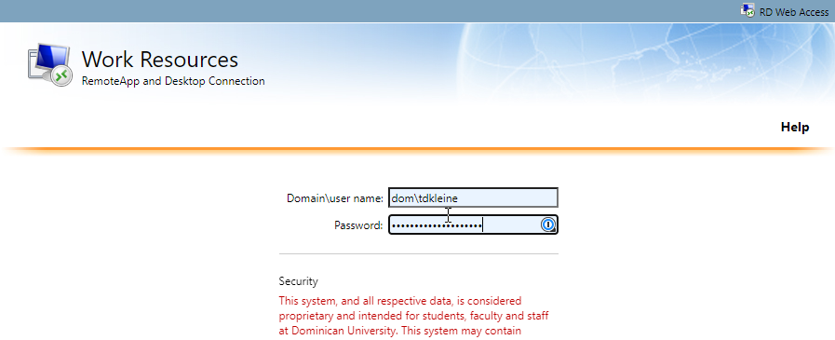
- Click on the program you wish to use. After you click (1), a remote desktop file will download to your machine (2). Click on the file to launch the program:
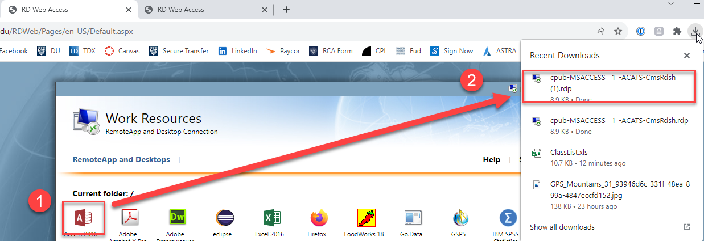

- Then, enter the following data and click sign in:
  - In username, enter dom\ and then your username (ex: dom\tdkleine).
  - In password, enter your email password:
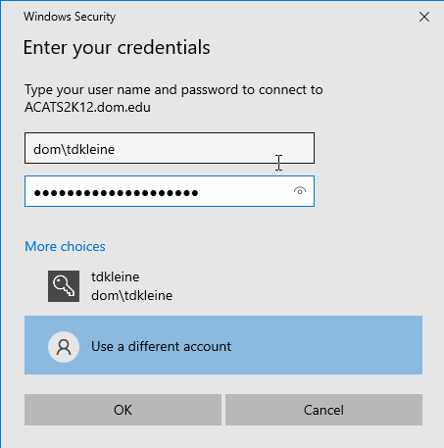
Please note: If you are using a Mac on campus, please visit this link for additional information.

From Off-Campus using Windows:
To access the software, you must first be enrolled in multi-/two-factor authentication (MFA) for your DU username and password. Enrollment is easy and must be completed by all students by October 15, 2023. For directions on how to enroll, click on this link. Once you are enabled for MFA, you must download DU’s VPN (Virtual Private Network) client, Global Protect. For directions on how to download and configure Global Protect, click on this link.
Once you are enrolled in MFA and have the VPN/Global Protect software downloaded to your machine, follow these steps:
- Open a web browser and go to https://remoteapp.dom.edu
- Enter the following data and then click Sign in:
  - In Domain\username, enter dom\ and then your username (ex: dom\tdkleine).
  - In password, enter your email password.
- Click on the program you wish to use. After you click (1), a remote desktop file will download to your machine (2). Click on the file to launch the program:

- Then, enter the following data and click sign in:
  - In username, enter dom\ and then your username (ex: dom\tdkleine).
  - In password, enter your email password:
Please note: If you are using a Mac on campus, please visit this link for additional information.

