Defining your site to Dreamweaver

Dreamweaver needs to know the location of the pages on your computer and it needs to know where your web host is located and how to access your web host so that it can perform file transfers. This information is specified to Dreamweaver by creating a new site.

Click on the Site item in the Dreamweaver menu to define your site to Dreamweaver and Select the item “New Site”
Type any name that is meaningful you in the Site Name Box.
Next, you need to tell Dreamweaver where the files for your site are located. If you have not created web pages yet, you need to point Dreamweaver to an empty directory where you are going to place your files later. Click the folder icon and use the normal Windows dialog boxes to select the folder where your web pages are or will be located.
If you are going to work at Dominican or on ACATSNEW, you should select a location on your n: drive. If you are going to use your own machine that is not connected to the Dominican Network, use a location on your c: drive.
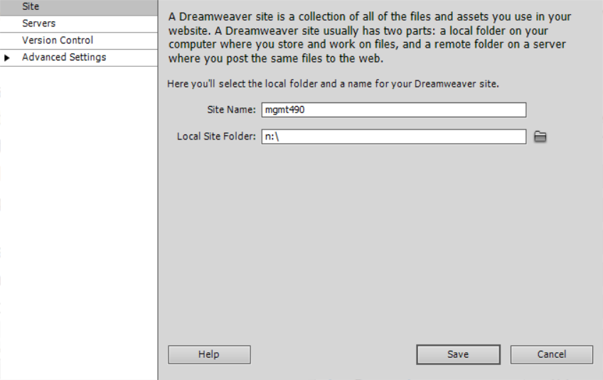
Next, click on Servers in the upper left in order to tell Dreamweaver where to upload your documents to your web host.
Once you have clicked on Servers, find the “+” in the dialog box and click it to specify the server at your web host.
You can choose any name you want for Server Name. If you are a professional web site developer that uses many servers, this name helps you remember them.
The FTP address is determined when you obtain a hosting account. We are using my hosting account and the name ftp.dombsb.com is required to access it.
As the owner of the host account, I have defined multiple users that can access various parts of the file system within my hosting space. Your username gives you read and write access to your area of the host.
Specify the Username as group49@dombsb.com
Your password is the same as your group number with an asterisk (shift+8) appended after then 9 (group49*).
The Web URL is the address that the rest of the world will use to access your web site.
Specify http://www.dombsb.com/mgmt490
address was determined as follows:
- The domain name (dombsb) is the name that I licensed and registered at the Domain Name Registrar directnic.com. I then told directnic to point this name to my hosting account at my web host (Midphase.com)
- The directory mgmt490 is the directory that I allocated for use by our class.
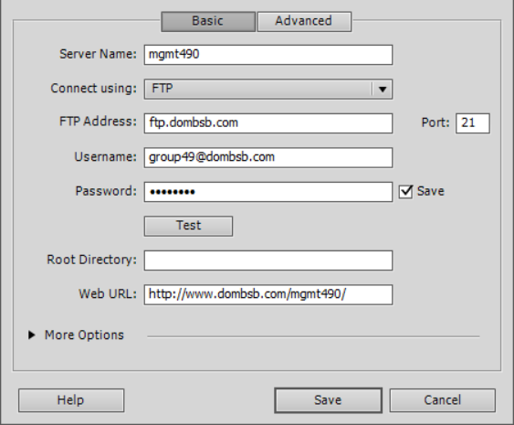
After you have filled in all the boxes, click on “More Options” and then check the Box “Use Passive FTP”. This increases the chances that the connection from your computer to the web host will work successfully. In rare cases, you will have to uncheck “Use FTP performance optimization” to get the connection to work.
Finally, click the test button to see if you site is properly defined and will connect to your web host. If not successful, go back to the beginning and check everything.
If successful, set Dreamweaver to use the site you just defined by specifying the site name near the upper right. In the picture below, look for “mgmt490” just below the tab called “Files”
