Remote Access to Dominican Server acatsnew.dom.edu from a MAC. Version 3: July 10, 2019
Please send comments and change requests to me at Jim Miller jmiller@dom.edu.

Major Steps
- Download Microsoft Remote Desktop
- Configure a gateway in Microsoft Remote Desktop
- Define your profile in Microsoft Remote Desktop
- Access the Dominican Server defined in your profile
- Begin working just as if you were at the keyboard of the machine acatsnew.dom.edu

Details

Download Microsoft Remote Desktop
1a. Go to the Apple App Store in you MAC.
1b. Sign in with your Appleid and password if asked.
1c. Search for Microsoft Remote Desktop.
1d. Select Microsoft Remote Desktop Business. You might see two similar looking icons for Microsoft Remote Desktop Business. Make sure to select and download Microsoft Remote Desktop Version 10. Version 8 is obsolete.
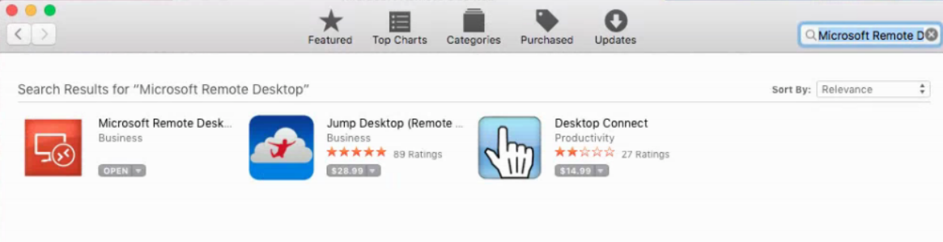
1e. Download and install Microsoft Remote Desktop
1f. Start Microsoft Remote Desktop

2. WARNING: THE NAME OF THE COMPUTER HAS CHANGED FROM ACATSNEW.DOM.EDU TO acats2k12.dom.edu. Do not use acatsnew.dom.edu Use the new name. The video you are about to watch is out-of-date
Configure Microsoft Remote Desktop using the video http://www.millerjw.com/dom/remotedesktop/remotedesktop/remotedesktop.mp4
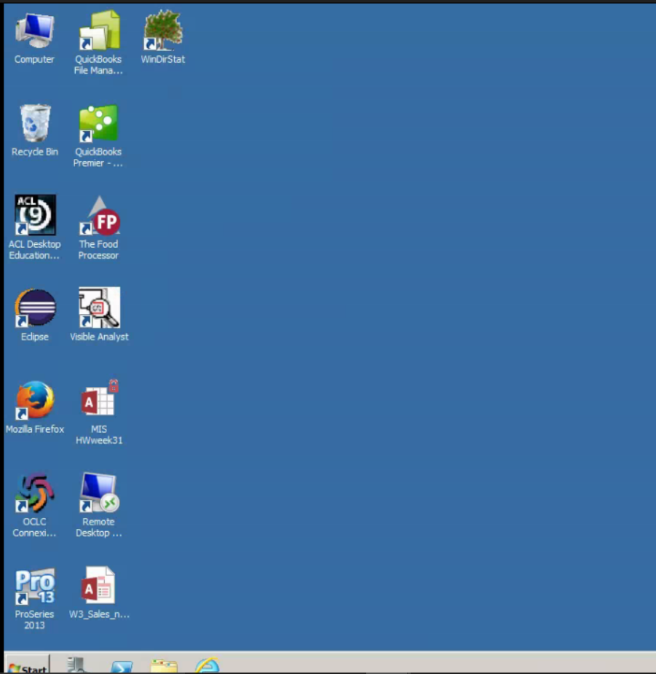

Begin working just as if you were at the keyboard of the machine acats2k12.dom.edu2a.

Start a browser and login to Canvas
2b. Open the homework and download whatever you need. You can save it on the desktop of acats2k12.dom.edu or on your n: drive.
5c. Do the homework. Double click on the database file that you saved from Canvas. This will open Access and load the database you were given. Add table definitions, data, and diagrams as required. As you are doing this, the database on the desktop is being automatically updated.
5d. Close Microsoft Access. (Do not leave it open or the next step could fail)
5d. Attach the database on the desktop to the homework question in Canvas. Submit the homework.

